Comparing Time Spent on Work

## Work finished between September 2014 and February 2015

***Includes*** *Keyblade and Infrastructure*

***Excludes*** *Ashburton and PineCone*

|  |  |  |  |
| --- | --- | --- | --- |
| **Work Type** | **Number of Cards** | **Total Days Spent** | **Average Days Spent** |
| Bug | 4 | 18 | 4.5 |
| Story | 40 | 558 | 13 |
| **Grand Total** | **44** | **576** |  |

## Work finished between September 2015 and March 2016

|  |  |  |  |
| --- | --- | --- | --- |
| **Work Type** | **Number of cards** | **Total Days spent** | **Average days spent** |
| Bug | 9 | 52 | 5.8 |
| Failure Demand | 3 | 23 | 7.7 |
| Investigation | 12 | 38 | 3.2 |
| Operational Demand | 1 | 9 | 9.0 |
| Story | 61 | 595 | 9.8 |
| **Grand Total** | **86** | **717** |  |

### Observations

* Cycle time has been reduced: previously a story would take nearly 3 weeks, now it’s taking 2 (given a 5-day week).
* Time spent in Accept is very similar, however the time spent in Build and Over Production has reduced significantly.
* Looking at number of cards, the team is also completing more work in a similar time period (or perhaps just visualizing more).

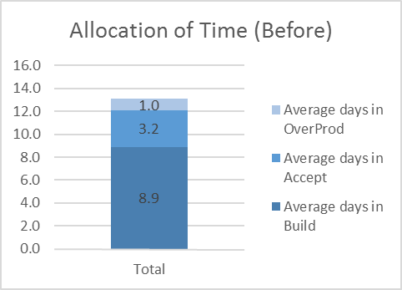 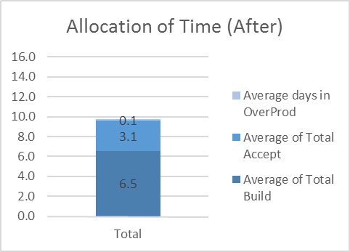

Comparing Productivity of Time in Build

## Work finished between September 2014 and February 2015

***Includes*** *Stories only (yellow cards)*

|  |  |  |  |  |  |
| --- | --- | --- | --- | --- | --- |
| **Work Stream** | **Days busy** | **Days not busy** | **Days blocked** | **Days waiting for test** | **Total days in Build** |
| Infrastructure | 121 | 19 | 44 | 7 | 191 |
| Treasury | 106 | 66 | 3 | 15 | 190 |
| **Grand Total** | **227** | **85** | **47** | **22** | **381** |
|  | **60%** | **22%** | **12%** | **6%** |  |

## Work finished between September 2015 and March 2016

***Includes*** *Stories only (yellow cards)*

|  |  |  |  |
| --- | --- | --- | --- |
| **Days busy** | **Days not busy** | **Days waiting for test** | **Total Days in Build** |
| 299 | 88 | 12 | 399 |
| **75%** | **22%** | **3%** |  |

### Observations

* Comparing previous with current we can see that the ratio of busy to not busy has moved considerably from 60% to 75%.
* “Blocked” time is no longer tracked, so one could assume the 2015/2016 Days not Busy (22%) would include blocked time.
* Time spent waiting for testing has reduced by 100%.

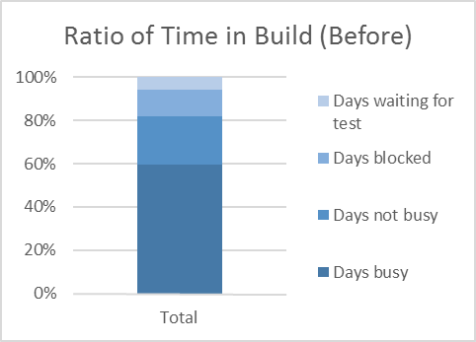 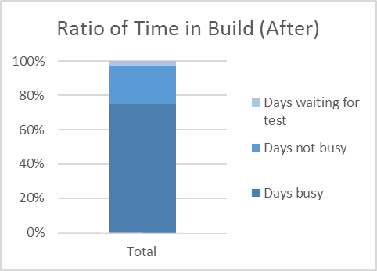

Comparing Productivity of Time in Accept

## Work finished between September 2014 and February 2015

***Includes*** *Stories only (yellow cards)*

|  |  |  |  |  |
| --- | --- | --- | --- | --- |
| **Work Stream** | **Days busy** | **Days not busy** | **Days blocked** | **Total days in Accept** |
| Infrastructure | 50 | 4 | 6 | 60 |
| Treasury | 61 | 15 | 1 | 77 |
| **Grand Total** | **111** | **19** | **7** | **137** |
|  | **81%** | **14%** | **5%** |  |

## Work finished between September 2015 and March 2016

***Includes*** *Stories only (yellow cards)*

|  |  |  |
| --- | --- | --- |
| **Days busy** | **Days not busy** | **Total days in Accept** |
| 159 | 28 | 187 |
| **85%** | **15%** |  |
|  |  |  |

### Observations

* Comparing previous with current we can see that the ratio of busy to not busy has improved slightly from 81% to 85%.
* “Blocked” time is no longer tracked, so one could assume the 2015/2016 Days not Busy (15%) would include blocked time.

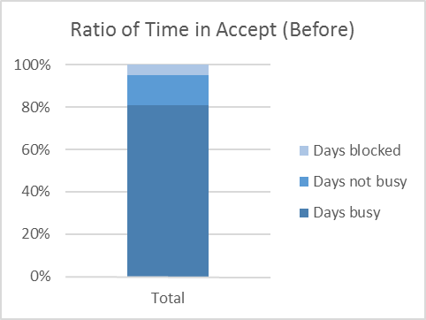 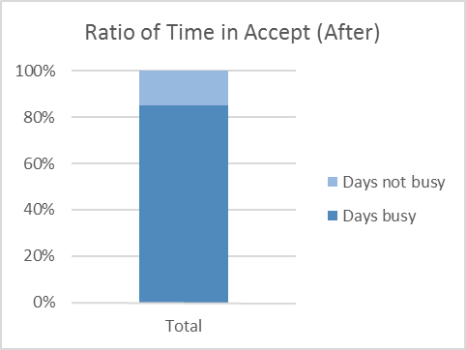

Comparing Cycle Time

# Simplified Comparison

***Includes*** *Stories only (yellow cards)*

# CompleteComparison

***Includes*** *Stories only (yellow cards)*